Global systems (answers)

Instructions to students  • You have 50 minutes to complete the test.  • Please answer all questions in the spaces provided.  • There is to be no talking during the test. | Marks  Section I: Multiple-choice questions: 10 marks  Section II: Short-answer questions: 33 marks  Section III: Extended-response questions: 7 marks  Total: 50 marks

Name: ________________________________________________________  Class: _________________________________________________________ | Score: /50  Grade: %
Comments:

Section I: Multiple-choice questions
For each question, circle the correct answer.
1 All of Earth’s water makes up the: |  | 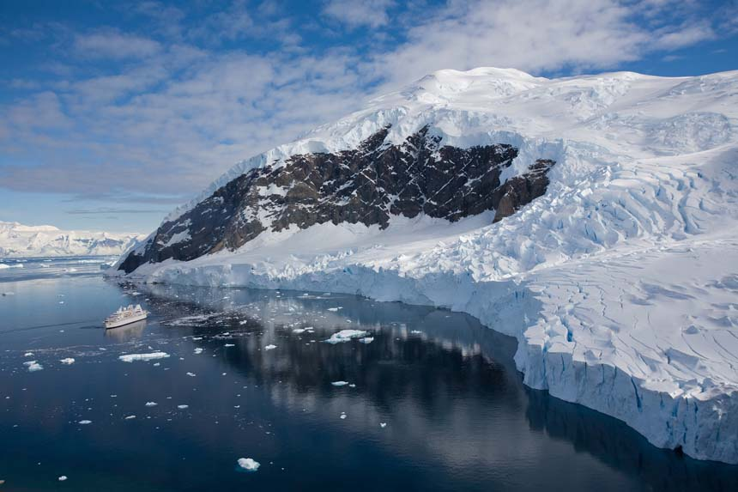
A | hydrosphere.
B | biosphere.
C | lithosphere.
D | atmosphere.
2 The most important gas for the survival of all animals is:
A | nitrogen.
B | carbon dioxide.
C | oxygen.
D | ozone.
3 Which sphere of the atmosphere is the thickest?
A | Mesosphere
B | Troposphere
C | Ionosphere
D | Stratosphere
4 Which of Earth’s sphere is the outermost layer, which merges with space?
A | The lithosphere
B | The mesosphere
C | The stratosphere
D | The exosphere

5 Bacteria, found in the root nodules of legumes, are essential in the cycling of: |  |  | 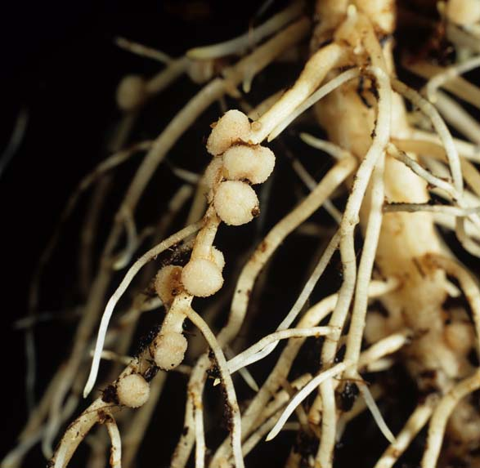
A | water.
B | nitrogen.
C | oxygen.
D | phosphorus.
6 Climate change is affecting people’s health. Which of the following statements is incorrect?
A | Infection zones for diseases that thrive in warm, moist conditions are increasing.
B | Urban sprawl is impeding the growth of hospitals and health facilities.
C | Higher temperatures are increasing heat-related fatalities.
D | Stagnant weather conditions can trap warm air and smog, leading to respiratory problems.
7 Which of the following is not a carbon sink?
A | Rocks and other carbonates
B | Organic matter in the soil
C | Atmosphere
D | Oceans
8 Which of the following devices is used to measure wind? |  | 
A | Anemometer
B | Thermometer
C | Barometer
D | Colorimeter

9 Wind is caused by differences in air pressure, mainly as a result of:
A | Earth’s rotation.
B | the gravitational pull of the Moon.
C | unequal heating of Earth’s surface.
D | Earth’s magnetic field.
10 The most damaging effect of the permafrost melting would be: |  | 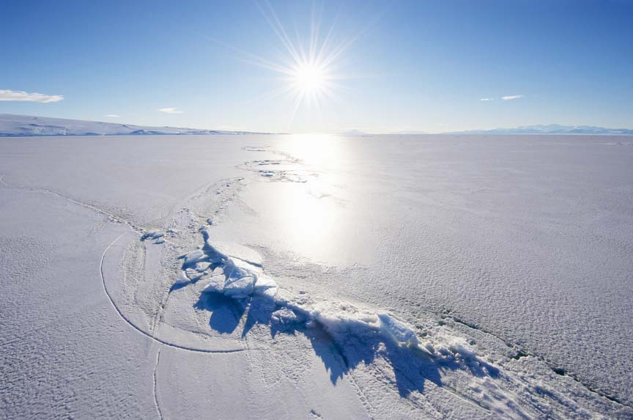
A | having nowhere to ski anymore.
B | sea levels rising due to the extra water.
C | massive changes to the world’s tides.
D | the release of large amounts of carbon into the atmosphere.
Section I total marks:
/10 marks

Section II: Short-answer questions
11 In the atmosphere, oxygen is formed through UV light converting water to oxygen and hydrogen. Name this process, labelled X on the diagram below, and write a chemical equation for this reaction.
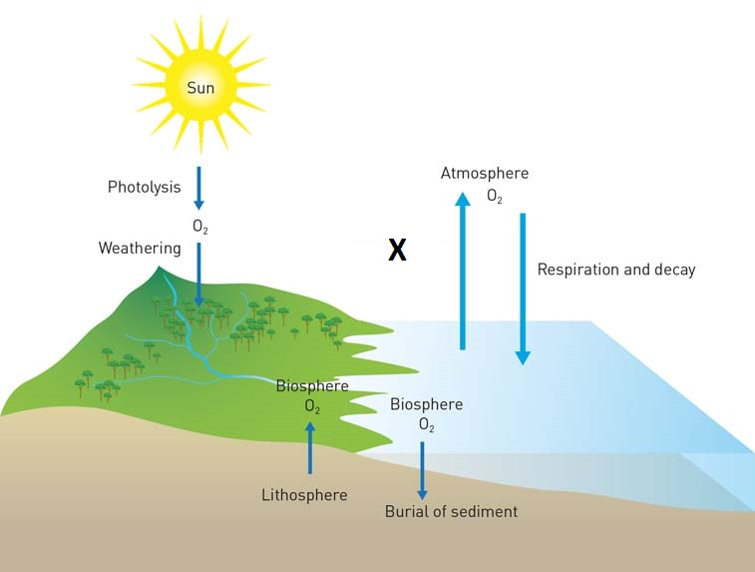
X: photolysis (1 mark)
2H2O + energy 2H2 + O2 (2 marks if energy included and balanced)
/3 marks

12 How do photosynthesis and respiration contribute to the oxygen cycle?
Plants release oxygen back into the atmosphere during photosynthesis (1 mark) to be used by animals during respiration (1 mark).
 |  | /2 marks
13 What is the difference between climate and weather?
‘Climate’ is a term used for the long-term atmospheric conditions, and ‘weather’ is a short-term snapshot of these conditions.
 |  | /2 marks
14 Name the Earth’s four major spheres.
Atmosphere, biosphere, hydrosphere, lithosphere
 |  | /4 marks
15 Explain why regions near the equator are warmer than regions near the poles.
At the equator, the Sun is directly overhead, and so the energy from it is concentrated. At the poles, the Sun is lower in the sky, and so energy from it comes at an angle and is more spread out.
 |  | /2 marks
16 Explain how a cyclone forms.
As hot air rises, air over a warm sea may heat up and rise rapidly. This causes colder air to rush into the vacated space quickly, which can create the spiral motion of a cyclone.
 |  | /2 marks
17 Phosphorus is no longer included in detergents to reduce eutrophication.  Explain how excess phosphorus from detergents contributed to increased eutrophication in waterways. | 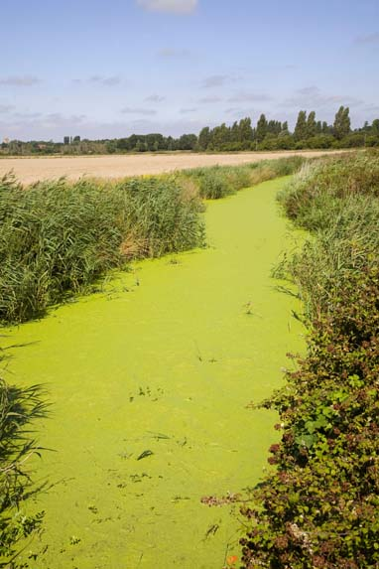  Eutrophication in an irrigation channel
Excess phosphorous in detergents enters waterways and causes increased plant growth of algae/plankton/aquatic plants (1 mark). The plants use more oxygen in photosynthesis, reducing the amount of oxygen within waterway for other organisms (1 mark), suffocating fish and blocking sunlight from organisms living deeper in the water (1 mark).
 |  | /3 marks

18 Give two ways in which humans have contributed to the enhanced greenhouse effect.
Humans have contributed to the enhanced greenhouse effect by burning fossil fuels and thus releasing carbon, and by clearing forests that would normally absorb some of the carbon.
/2 marks
19 Identify the major process (A–D) that continually cycle water through the hydrosphere, atmosphere and biosphere.
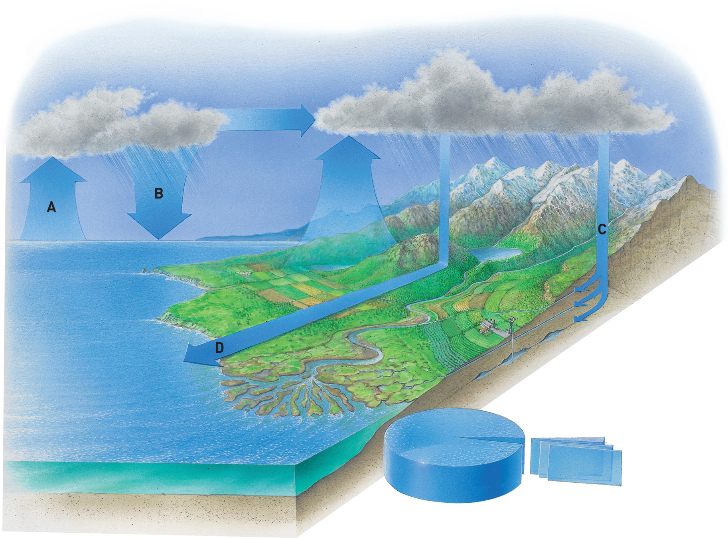
A: evaporation
B: precipitation
C: infiltration
D: surface run-off
/4 marks
20 What is a carbon sink? Why are these so important?
A carbon sink is any feature of the environment that absorbs and/or stores carbon, keeping it from the atmosphere. Carbon sinks are important because without them there would be much more carbon in the atmosphere, dramatically increasing the greenhouse effect.
/2 marks
21 Explain the role of bacteria in the nitrogen cycle.
Nitrogen-fixing bacteria convert atmospheric nitrogen into usable forms. Denitrifying bacteria return the nitrogen to the atmosphere.
/2 marks
22 Distinguish between the hydrosphere and the cryosphere.
The hydrosphere is made up of all of Earth’s water. The cryosphere is a part of the hydrosphere, made up of all of Earth’s frozen water.
/2 marks

23 Give three negative effects of melting sea ice.
Any reasonable answer, such as: melting sea ice causes the water level to rise, resulting in flooding of coastal areas; sea ice reflects sunlight, and so less sea ice means that the temperature of the Earth will rise more quickly; sea ice is essential to the habitat of animals like penguins and polar bears, who could face extinction if it all melts.
/3 marks
Section II total marks:
/33 marks

Section III: Extended-response questions
18 Using examples, describe how two different observations or measurements have been made by humans to provide evidence of enhanced global warming.
Evidence and examples will vary.
For example:
Rising sea levels (1 mark): there has been a dramatic increase in sea levels over the past 100 years as a result of enhanced global warming melting ice at the polar ice caps (1 mark).
Extinction (1 mark): the white lemuroid possum cannot survive extended temperatures over 30°C and has not been seen for over 3 years (1 mark).
Other evidence could include increased temperature of permafrost, increased carbon emissions, loss of biodiversity, coral bleaching, and the increase in the incidence of extreme weather conditions.
/4 marks

20 There are many practices now being carried out to reduce global warming. Identify and describe ONE practice aimed at reducing global warming. Explain how your selected practice reduces global warming.
Students answers will vary based on selected method.
Method identified (1 mark); description of method (1 mark); how it reduces global warming (1 mark).
For example, carbon farming (1 mark) is growing plants that will not be used for any purpose such as firewood and building (1 mark). This removes carbon from the atmosphere during photosynthesis, locking the carbon within the plant while it lives (1 mark).
/3 marks
Section III total marks:
/7 marks

